**Major Project**

**1st Review Report**

**On**

**Customer Satisfaction Based On Their Queries For Business Development**

**1201310056 – Mohit Ratnesh**

**1201310057 – Sourabh Agarwal**

**Abstract**

Our system is mainly focusing on the implementation of web application through which user can able to extract their required information of the restaurants by providing some queries to filter the data from the different social networking sites currently available in the market.  
We will be using decision tree and neural networking technologies to achieve our required built of the system. It will help in getting the best restaurants among all within a city in a moment of a click.

**LITERATURE REVIEW**

|  |  |  |  |
| --- | --- | --- | --- |
| **Title** | **Author** | **Published Date** | **Algorithm** |
| **Evaluation Of Customer Satisfaction Using the Quality Function Deployment** | **Marcela Pavlickuva** | **2015** | **ANOVA analysis and Customer Windows** |
| **Data Mining for Predicting Customer Satisfaction in Fast Food Restaurant** | **Bayu Adhi Tama** | **2015** | **Neural Network and Decision Tree** |
| **Evaluation of Service Quality based On Customer Satisfaction** | **Jing Hua Shi Qiang Su** | **2007** | **Customer Satisfaction Degree (CSD) and Service**  **Quality Evaluation** |
| **Objective:**  **Service quality plays an important role while determining customer satisfaction.**  **Apart from it ,its environment,safety and ambience also are some reasonable factors for customer satisfaction which we can derive by using decision tree and neural network techniques.** | | | |

**Requirement Analysis**

* **Functional Requirement**  
  1) Queries  
   - Type of Restaurant(veg/non-veg)  
   - Availability of Different Cuisines  
   - Availability of Different Price Range  
   - Should work for different cities  
    
  2) User Credentials  
   - User details for taking Feedback  
    
  3) Filters should be optimized
* **Non Functional Requirement**

1. Security
2. Performance
3. User Friendly Interface
4. 24x7 Availability

**Cost Estimation**

* Estimated LOC using the use case estimation = 22,400
* Then using COCOMO Model , Effort=80.99
* And taking Rs 10 per LOC we will have Rs 80,990
* And using BOHEM’s Model, Effort=83.73
* And taking Rs 10 per LOC we will have Rs 83,730

Architecture Diagram & Architecture System

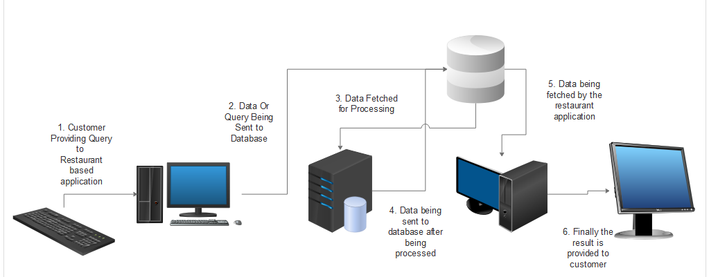

Architecture Style

Hybrid Type (Pipe & Filters, Data Centralized)

User Interface

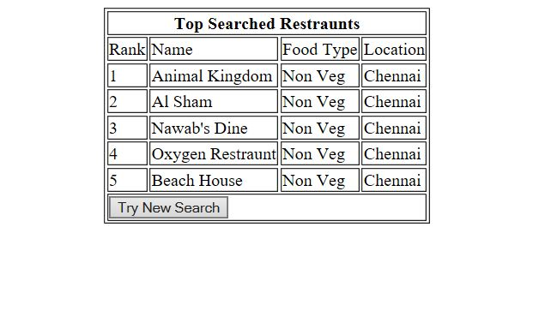

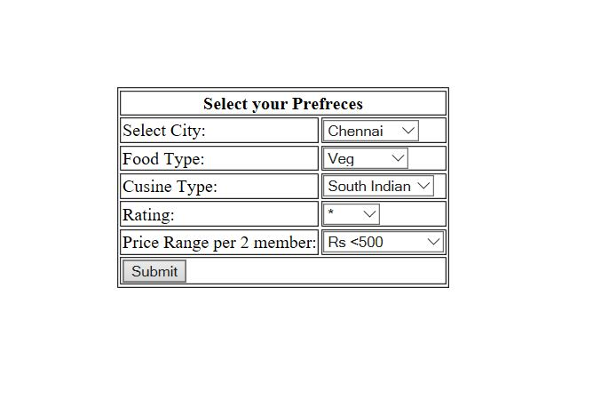

Data Flow Diagram

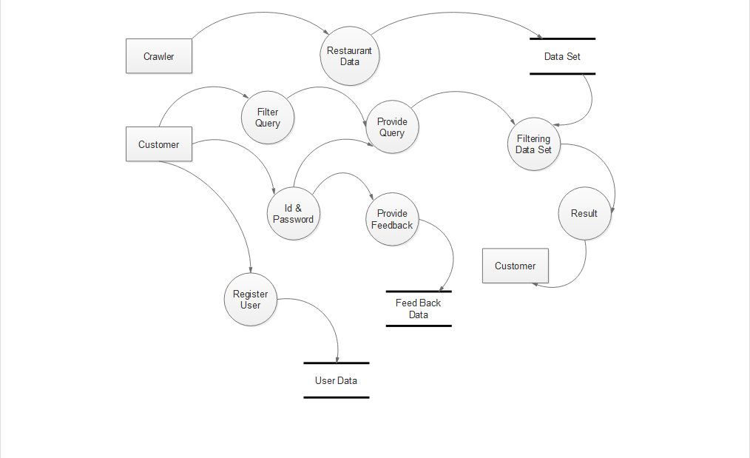

Class Diagram

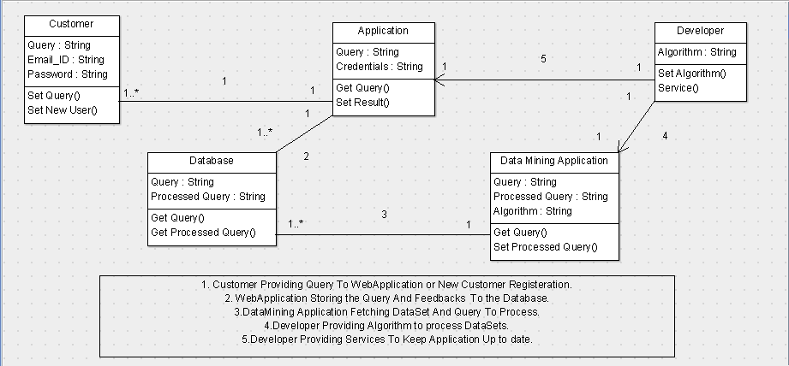

Sequence Diagram

